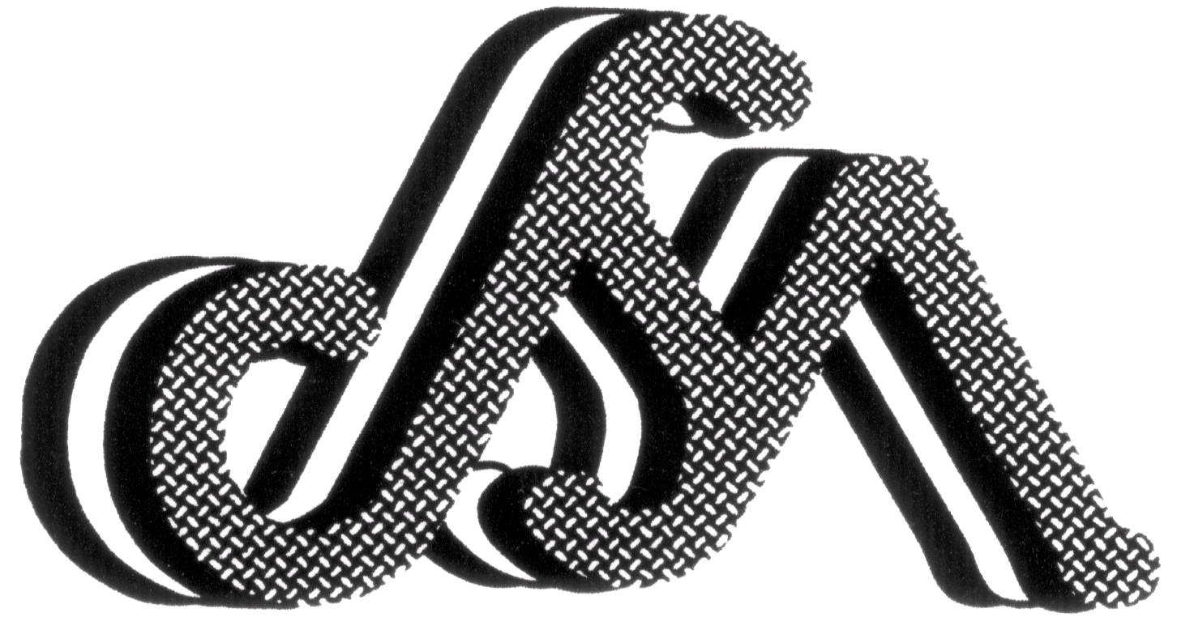

COPYRIGHT CLEARANCE/TRANSFER FORM
For 16th International Conference on Composite Materials (ICCM-16)
July 8-13, 2007, KICH, Kyoto, JAPAN

To be signed and submitted along with the paper manuscript by April 30, 2007 via e-mail.

REVIEW AND ACCEPTANCE:
All papers are subject to review by the publication committee of ICCM-16. Receipt of a paper is not a commitment for its publication. All papers accepted are subject to editing and become the property of the Japan Society for Composite Materials (JSCM).

DUE DATES AND ADDRESSES:
An electronic file of PDF of the original final manuscript copy must be received by the local organizing committee of ICCM-16, before April 30, 2007, to iccm16paper@chofu.jaxa.jp. If you do not have web access the electronic files may also be sent by postal mail on 1.44 MB floppy or CD-R / CD-RW, to the following address:
ICCM-16 Local Committee Office, Advanced Composites Center, JAXA Chofu Branch,
6-13-1 Ohsawa, Mitaka, Tokyo 181-0015, JAPAN

CLEARANCE AND TRANSFER:
It is the responsibility of the authors to secure such company approvals and government clearance as may be required. Hence, the copyright shall be transferred to the JSCM.

SOCIETY RESPONSIBILITY:
Statements and opinions advanced in papers are to be understood as individual expressions of their respective authors, and not those of the JSCM.

PUBLICATION BY OTHERS:
Permission to publish papers elsewhere must be requested in writing to the JSCM by either the author or the publisher. When granted, an acknowledgment to ICCM-16 and the JSCM must be made by the publisher.

AUTHOR’S EXPENSES:
The JSCM does not pay expenses incurred by authors in connection with the preparation of papers and attendance at the ICCM-16 Conference.
………………………………………………………………………………………….
I herewith submit a paper entitled:
to the Japan Society for Composite Materials, in accordance with the above conditions.

Full Name of the Presenter:

Full Name of the Representing Author:

Signature of the
Representing Author Date (dd:mm:yy)

The author is requested to submit this form simultaneously with the paper submission to the same address as above. This form shall be converted into a pdf file initiated by a combination of the session indicator prefix (one of ge, sp, or pl) and your paper ID number in a six digit format followed by ‘ct.pdf’ in lower case. For example, copyright transfer of ID 100121 in general session would have the title, ‘ge100121ct.pdf’. If he fails to submit this form, the paper would not appear in the CD-ROM.

