ANNOUNCEMENT

The Six-th Korea-Japan Joint Symposium on Composite Materials
Pohang University of Science and Technology
Pohang, Korea, November 1, 2007

organized by the Korean Society for Composite Materials
in cooperation with the Japan Society for Composite Materials

Since the first Japan-Korea Joint Symposium on Composite Materials was held in Sapporo, Japan in the year 2000, the five times Korea-Japan Joint Symposia have been alternatively held as an annual event in Korea and Japan. 253 papers in the five times Symposia have been presented, which were very successful owing to not only the high quality of papers but also the eager participation especially. The Sixth Joint Symposium will be held at the Pohang University of Science and Technology in Pohang, Korea. Pohang is located about 400 kilometers southeast of Seoul, Korea and is famous for POSCO. Founded back in 1968 with virtually no capital, technology or experience, POSCO has risen to the top of the global steel industry for just three decades. POSCO produces some 28 million tons of steel products each year, enough to produce about 100,000 compact cars a day. Near Pohang there is Kyongju which used to be the capital of Silla Kingdom that lasted for approximately 1,000 years from 57 B.C. until A.D. 935. The city is today often called the “museum without walls.” It is filled with innumerable historical sites, relics and artifacts. And new archaeological discoveries are still being made. The joint symposium aims at the cooperative efforts by the composites communities of both countries in soliciting for works of various research topics and in promoting the participation of scientists, engineers and students. All topics and all the scientific/technological approaches for composite materials are pertinent to this joint symposium.

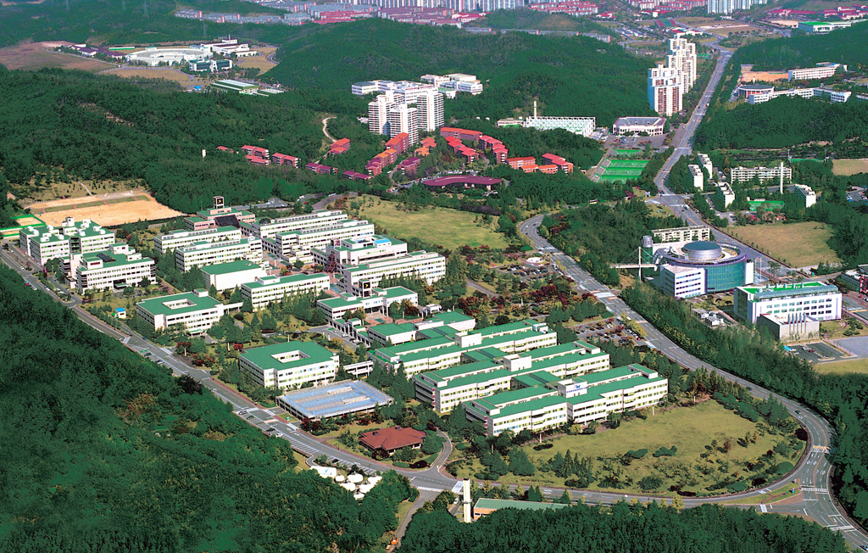
Registration
The registration fee for a Japanese participant costs 50,000 Won which includes one copy of the Symposium Proceedings and one banquet ticket.

Technical Sessions
The symposium working language is English and the two pages proceedings manuscripts must be written in English. Topics include, but are not limited to Session A: Materials and Processing, Session B: Design and Applications, Session C: Properties and Durability and Session D: Nanocomposites and Nanostructures.

Schedule and Location
Due date for application of paper titles, author names and institutions: July 31, 2007
Due date for submission of two pages manuscripts: September 31, 2007.
Get Together Party: October 31, 2007
Joint Symposium and Buffet Reception: November 1, 2007
Technical Tour: November 2, 2007

The Joint Symposium will be held on the campus of Pohang University of Science and Technology (POSTECH), which is located about 30 minutes away from the Pohang Airport by taxi. Since there is no international airline to Pohang directly, you must first get to Seoul or Busan by air and come to Pohang by air or bus. There are 6 flights a day from the Gimpo Airport in Seoul to the Pohang Airport which takes about 50 minutes. 11 limousine buses daily run from the Gimhae Airport in Busan to Gyeongju. Gyeongju is located about 30 kilometers southwest of Pohang. Intercity buses connect Pohang with Gyeongju. Passengers who want to take a limousine bus have to get it on at Limousine Bus Stop 2 in the Gimhae Airport. As far as accommodation is concerned, new announcements will be followed during August. For further information, please contact:

Contact persons in Korea and Japan
Prof. Nak-Sam Choi: nschoi@hanyang.ac.kr Prof. Naoyuki Watanabe: wata@aswat1.tmit.ac.jp
Department of Mechanical Engineering Department of Aerospace Engineering
Hanyang University Tokyo Metropolitan University
Sa-1-dong, Ansan, Kyunggi-do 426-791, Korea Asahigaoka 6-6, Hino, Tokyo 191-0065, Japan
Tel: +82-31-400-5283 Fax+82-31-406-5550 Tel/Fax: +81-42-585-8661

